# Converter in WPF

# ValueConverters

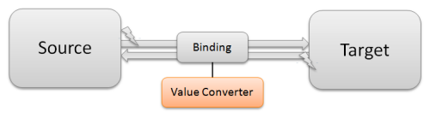

## Introduction

If you want to databind two properties that have incompatible types, you need a piece of code in between, that converts the value from source to target type and back. This piece of code is called ValueConverter. A value converter is a class, that implements the simple interface IValueConverter with the two methods object Convert(object value) andobject ConvertBack(object value).

## How to implement a ValueConverter

WPF already provides a few value converts, but you will soon need to implement your own converts. To do this, add a class to your project and call it [SourceType]To[TargetType]Converter. This is a common naming for value converters. Make it public and implement the IValueConverter interface. That's all you need to do.

**public** **class** BoolToVisibilityConverter : IValueConverter

{

**public** **object** Convert(**object** value, Type targetType,

**object** parameter, CultureInfo culture)

{

// Do the conversion from bool to visibility

}

**public** **object** ConvertBack(**object** value, Type targetType,

**object** parameter, CultureInfo culture)

{

// Do the conversion from visibility to bool

}

}

## How to use a ValueConverter in XAML

First thing you need to do is to map the namespace of your converter to a XAML namespace. Then you can create an instance of a value converter in the resources of the view and give it a name. Then you can reference it by using{StaticResource}

<Window x:Class="VirtualControlDemo.Window1"

...

xmlns:l="clr-namespace:VirtualControlDemo"

...>

<Window.Resources>

<l:BoolToVisibilityConverter x:Key="converter" />

</Window.Resources>

<Grid>

<Button Visibility="{Binding HasFunction,

Converter={StaticResource converter}}" />

</Grid>

</Window>

## Simplify the usage of ValueConvers

If you want to use a normal ValueConverter in XAML, you have to add an instance of it to the resources and reference it by using a key. This is cumbersome, because and the key is typically just the name of the converter.

A simple and cool trick is to derive value converters from MarkupExtension. This way you can create and use it in the binding like this: Text={Binding Time, Converter={x:MyConverter}}, and that is quite cool!

**public** abstract **class** BaseConverter : MarkupExtension

{

**public** **override** **object** ProvideValue(IServiceProvider serviceProvider)

{

**return** this;

}

}

## StringFormat Converter

The StringFormatConverter is a useful converter to control the format of an implicit string conversion of an object (e.g. if you bind a DateTime to a TextBlock ).

[ValueConversion(**[typeof](http://www.google.com/search?q=typeof+msdn.microsoft.com)**(**object**), [**typeof**](http://www.google.com/search?q=typeof+msdn.microsoft.com)(**string**))]

**public** **class** StringFormatConverter : BaseConverter, IValueConverter

{

**public** **object** Convert(**object** value, Type targetType, **object** parameter,

System.Globalization.CultureInfo culture)

{

**string** format = parameter **as** string;

**if** (!**string**.IsNullOrEmpty(format))

{

**return** **string**.Format(culture, format, value);

}

**else**

{

**return** value.ToString();

}

**public** **object** ConvertBack(**object** value, Type targetType, **object** parameter,

System.Globalization.CultureInfo culture)

{

**return** null;

}

}

# [how to pass an integer as ConverterParameter?](http://stackoverflow.com/questions/3978937/how-to-pass-an-integer-as-converterparameter)

|  |  |
| --- | --- |
|  | I am trying to bind to an integer property:  <RadioButton Content="None"              IsChecked="{Binding MyProperty,                          Converter={StaticResource IntToBoolConverter},                          ConverterParameter=0}" />  and my converter is:  [ValueConversion(typeof(int), typeof(bool))] public class IntToBoolConverter : IValueConverter {     public object Convert(object value, Type t, object parameter, CultureInfo culture)     {         return value.Equals(parameter);     }      public object ConvertBack(object value, Type t, object parameter, CultureInfo culture)     {         return value.Equals(false) ? DependencyProperty.UnsetValue : parameter;     } }  the problem is that when my converter is called the parameter is string. i need it to be an integer. of course i can parse the string, but do i have to? |
|  |  |

## 

|  |  |
| --- | --- |
|  | Here ya go!  <RadioButton Content="None"              xmlns:sys="clr-namespace:System;assembly=mscorlib">     <RadioButton.IsChecked>         <Binding Path="MyProperty"                  Converter="{StaticResource IntToBoolConverter}">             <Binding.ConverterParameter>                 <sys:Int32>0</sys:Int32>             </Binding.ConverterParameter>         </Binding>     </RadioButton.IsChecked> </RadioButton>  The trick is to include the namespace for the basic system types and then to write at least the ConverterParameter binding in element form. |

# [How to pass specific value to the converter parameter?](http://stackoverflow.com/questions/5702737/how-to-pass-specific-value-to-the-converter-parameter)

|  |  |
| --- | --- |
|  | I have created a class Person that looks like this:  public class Person {     public enum GenderType     {         Female,          Male     }      public string Name     {         get; set;     }      public GenderType? Gender     {         get; set;     } }  Next, I created data template that is going to present objects of type Person. Here's XAML code:  <DataTemplate      x:Key="personTemplate"      DataType="{x:Type model:Person}">   <StackPanel>     <RadioButton          Content="Female"          IsChecked="{Binding Path=Gender,                      Converter={StaticResource genderConverter},                      ConverterParameter=???}"/>     <RadioButton          Content="Male"          IsChecked="{Binding Path=Gender,                      Converter={StaticResource genderConverter},                      ConverterParameter=???}"/>     <RadioButton          Content="Not specified"          IsChecked="{Binding Path=Gender,                      Converter={StaticResource genderConverter},                      ConverterParameter=???}"/>   </StackPanel> </DataTemplate>  Of course the ???s in the code won't work :) The problem is that I want to create a genderConverterconverter which will compare the given value, i.e. personObject.Gender, against the givenPerson.GenderType value provided in the parameter and return true if the values match.  I don't know how to make the converter parameter pass Person.GenderType.Female,Person.GenderType.Male and null, for the first, second and third radio button, respectively. |
|  |  |

|  |  |
| --- | --- |
|  | Try using x:Static markup extension:  <RadioButton          Content="Female"          IsChecked="{Binding Path=Gender,                      Converter={StaticResource genderConverter},                      ConverterParameter={x:Static model:GenderType.Female}}"/>  OR, you could just pass a string and use Enum.Parse to convert that string to the enum type in the converter:  <RadioButton          Content="Female"          IsChecked="{Binding Path=Gender,                      Converter={StaticResource genderConverter},                      ConverterParameter=Female}"/>  -  GenderType gender = (GenderType)Enum.Parse(typeof(GenderType), parameter.ToString()); |

### WPF - Binding Converter Parameter [Including Discussion about Binding Reflector]

In this post we will be discussing how we can bind *ConverterParameter*used in WPF Binding. As we know that *ConverterParameter*is not a *DependencyProperty*, we can not bind it directly. We will be looking at the possible workarounds to achieve the similar results. As always, we will start with a simple window and then add necessary ingredients for this discussion. Let us create a sample Window with two text boxes for entering Gender and Name of a Student.

<Window x:Class="WpfApplication_ConverterParameterBinding.MainWindow"  
 xmlns="http://schemas.microsoft.com/winfx/2006/xaml/presentation"  
 xmlns:x="http://schemas.microsoft.com/winfx/2006/xaml"  
 xmlns:local="clr-namespace:WpfApplication_ConverterParameterBinding"  
 Title="Main Window" Height="350" Width="525">  
 <Window.DataContext>  
 <local:MainWindowViewModel />   
 </Window.DataContext>  
 <Grid>  
 <TextBox Height="30" HorizontalAlignment="Left" Margin="84,6,0,0" Name="textBoxGender"   
 VerticalAlignment="Top" Width="412" >  
 <TextBox.Text>  
 <Binding Path="Gender" UpdateSourceTrigger="PropertyChanged" Mode="TwoWay" />   
 </TextBox.Text>  
 </TextBox>  
 <Label Content="Gender" Height="28" HorizontalAlignment="Left" Margin="12,6,0,0"  
 Name="labelGender" VerticalAlignment="Top" Width="58" />  
 <TextBox Height="30" HorizontalAlignment="Left" Margin="84,40,0,0" Name="textBoxStudentName"  
 VerticalAlignment="Top" Width="412" >  
 <TextBox.Text>  
 <Binding Path="StudentName" UpdateSourceTrigger="PropertyChanged" Mode="TwoWay" />  
 </TextBox.Text>  
 </TextBox>  
 <Label Content="Name" Height="28" HorizontalAlignment="Left" Margin="12,40,0,0"   
 Name="labelStudentName" VerticalAlignment="Top" Width="58" />  
 </Grid>  
</Window>

As you can see that we have used an instance of *MainWindowViewModel*as *DataContext*of the *Window*. *MainWindowViewModel*is presented as below:

namespace WpfApplication_ConverterParameterBinding  
{  
 using System.Windows;  
  
 class MainWindowViewModel : DependencyObject  
 {  
 public static DependencyProperty GenderProperty =  
 DependencyProperty.Register("Gender", typeof(string),  
 typeof(MainWindowViewModel), new FrameworkPropertyMetadata() { AffectsRender = true });  
  
 public string Gender  
 {  
 get { return (string)GetValue(GenderProperty); }  
 set { SetValue(GenderProperty, value); }  
 }  
  
 public static DependencyProperty StudentNameProperty =  
 DependencyProperty.Register("StudentName", typeof(string),  
 typeof(MainWindowViewModel), new FrameworkPropertyMetadata() { AffectsRender = true });  
  
 public string StudentName  
 {  
 get { return (string)GetValue(StudentNameProperty); }  
 set { SetValue(StudentNameProperty, value); }  
 }  
 }  
}

When we run this application, it appears as follows:  
  
[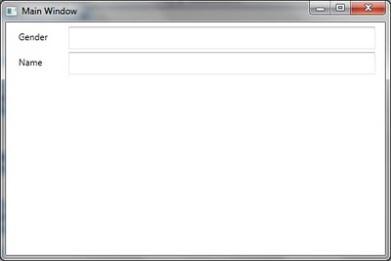](http://1.bp.blogspot.com/_fVxKMZVpfzU/TUuihHHDPGI/AAAAAAAAAvw/QG45tJHUJCI/s1600/1.jpg)  
  
Now we want to display a Welcome message to the Student based on the information entered. If it is a Male student (Gender = M), the message should be read as "Welcome Mr. NAME OF STUDENT". If it is a female student (Gender = F), it should read as "Welcome Ms. NAME OF STUDENT".  
  
[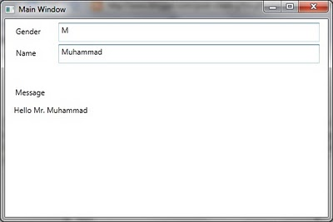](http://1.bp.blogspot.com/_fVxKMZVpfzU/TUul8J1DoJI/AAAAAAAAAwA/GfHCdvXwJJ0/s1600/2.jpg)  
In order to update the Window, let us add a TextBlock at the bottom as follows:

<Window x:Class="WpfApplication_ConverterParameterBinding.MainWindow"  
 xmlns="http://schemas.microsoft.com/winfx/2006/xaml/presentation"  
 xmlns:x="http://schemas.microsoft.com/winfx/2006/xaml"  
 xmlns:local="clr-namespace:WpfApplication_ConverterParameterBinding"  
 Title="Main Window" Height="350" Width="525">  
 <Window.DataContext>  
 <local:MainWindowViewModel />   
 </Window.DataContext>  
 <Grid>  
 <TextBox Height="30" HorizontalAlignment="Left" Margin="84,6,0,0" Name="textBoxGender"   
 VerticalAlignment="Top" Width="412" >  
 <TextBox.Text>  
 <Binding Path="Gender" UpdateSourceTrigger="PropertyChanged" Mode="TwoWay" />   
 </TextBox.Text>  
 </TextBox>  
 <Label Content="Gender" Height="28" HorizontalAlignment="Left" Margin="12,6,0,0"  
 Name="labelGender" VerticalAlignment="Top" Width="58" />  
 <TextBox Height="30" HorizontalAlignment="Left" Margin="84,40,0,0" Name="textBoxStudentName"  
 VerticalAlignment="Top" Width="412" >  
 <TextBox.Text>  
 <Binding Path="StudentName" UpdateSourceTrigger="PropertyChanged" Mode="TwoWay" />  
 </TextBox.Text>  
 </TextBox>  
 <Label Content="Name" Height="28" HorizontalAlignment="Left" Margin="12,40,0,0"   
 Name="labelStudentName" VerticalAlignment="Top" Width="58" />  
 <TextBlock Height="164" HorizontalAlignment="Left" Margin="14,135,0,0" Name="textBlockMessage"  
 Text="Hello Mr. Muhammad" VerticalAlignment="Top" Width="479" />  
 <Label Content="Message" Height="29" HorizontalAlignment="Left" Margin="11,102,0,0"  
 Name="label1" VerticalAlignment="Top" Width="129" />  
 </Grid>  
</Window>

The text is hardcode "Hello Mr. Muhammad. We want it to be based on the Data entered. First let us update the Binding that it just shows "Hello NAME OF STUDENT" message in the notification box.

<TextBlock Height="164" HorizontalAlignment="Left" Margin="14,135,0,0" Name="textBlockMessage"  
 VerticalAlignment="Top" Width="479" >  
 <TextBlock.Text>  
 <Binding Path="StudentName" StringFormat="Hello {0}" />  
 </TextBlock.Text>  
</TextBlock>

Now when we run the application, it shows a welcome message to the student.   
  
[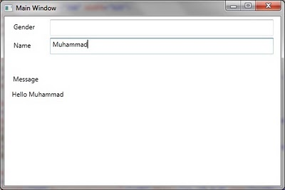](http://2.bp.blogspot.com/_fVxKMZVpfzU/TUuoLNDgzRI/AAAAAAAAAwI/IDu4orLTbG8/s1600/3.jpg)  
Since we want to show the salutation (Mr. / Ms.) with name so we need to somehow use Gender. if it is M, we should show "Welcome Mr. NAME OF STUDENT". On the other hand if it is F, we should show "Hello Ms. NAME OF STUDENT".  
Let us define an *IValueConverter*for this purpose:

namespace WpfApplication_ConverterParameterBinding  
{  
 using System;  
 using System.Windows.Data;  
  
 class MessageConverter : IValueConverter  
 {  
 public object Convert(object value, Type targetType, object parameter, System.Globalization.CultureInfo culture)  
 {  
 string salutation = (parameter == null || parameter == "M") ? "Mr." : "Ms";  
  
 return string.Format("Hello {0} {1}", salutation, value);  
 }  
  
 public object ConvertBack(object value, Type targetType, object parameter, System.Globalization.CultureInfo culture)  
 {  
 throw new NotImplementedException();  
 }  
 }  
}

Basically we are expecting that, somehow, we would be able to pass Gender as parameter of Converter. Let us instantiate the Converter in the *Resources*section of the window.

<Window.Resources>  
 <local:MessageConverter x:Key="messageConverter" />  
</Window.Resources>

This is used for Binding the converter as follows:

<TextBlock.Text>  
 <Binding Path="StudentName" Converter="{StaticResource messageConverter}" ConverterParameter="{Binding Gender}" />  
</TextBlock.Text>

This seems to pass Gender for *ConverterParameter*for Binding. But as we run the applcation, it results in an exception.  
  
[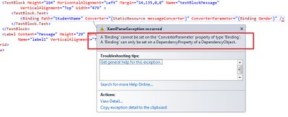](http://1.bp.blogspot.com/_fVxKMZVpfzU/TUus2-bc8tI/AAAAAAAAAwQ/3pYxF0I-jYM/s1600/4.jpg)  
  
This is because of the limitation as mentioned in the beginning of this post. Basically *ConverterParameter*is not a dependency property so we can not bind it. Now let us discuss the alternative solutions.  
  
**Using MultiBinding:**  
One way to resolve the issue of Binding *ConverterParameter*is by using *MultiBinding*. Instead of Binding *ConverterParameter*, just have a separate binding for *Target*property using *MultiBinding*. We would be needing *MultiValueConverter*for this purpose. We are expecting that the following converter would be used for MultiBinding (implements IMultiValueConverter) of Gender and Name property. If the values of none of these are available then return empty string. If any of these is available then greet the person [*Hello Mr. NAME_OF_PERSON* for Gender = M and *Hello Ms. NAME_OF_PERSON* for Gender = F]

namespace WpfApplication_ConverterParameterBinding  
{  
 using System;  
 using System.Windows.Data;  
  
 class MessageMultiConverter : IMultiValueConverter  
 {  
 public object Convert(object[] values, Type targetType, object parameter, System.Globalization.CultureInfo culture)  
 {  
 string name = (values[1] == null) ? string.Empty : values[1].ToString();  
 string gender = (values[0] == null) ? string.Empty : values[0].ToString();  
   
 string salutation;  
  
 switch(gender)  
 {  
 case "M":  
 salutation = "Mr";  
 break;  
 case "F":  
 salutation = "Ms";  
 break;  
 default:  
 salutation = string.Empty;  
 break;  
 }  
  
 string message = string.Empty;  
  
 if (!(name == string.Empty && gender == string.Empty))  
 {   
 message = string.Format("Hello {0} {1}", salutation, name);  
 }   
   
 return message;  
 }  
  
 public object[] ConvertBack(object value, Type[] targetTypes, object parameter, System.Globalization.CultureInfo culture)  
 {  
 throw new NotImplementedException();  
 }  
 }  
}

Let's use this converter in a view. The only update is the usage of this new converter. We are instantiating it in the *Resources*section of*Window*. We are using the same converter with text block showing Message.

<Window x:Class="WpfApplication_ConverterParameterBinding.MainWindowMultiBinding"  
 xmlns="http://schemas.microsoft.com/winfx/2006/xaml/presentation"  
 xmlns:x="http://schemas.microsoft.com/winfx/2006/xaml"  
 xmlns:local="clr-namespace:WpfApplication_ConverterParameterBinding"  
 Title="Main Window" Height="350" Width="525">  
 <Window.Resources>  
 <local:MessageMultiConverter x:Key="messageConverter" />  
 </Window.Resources>  
 <Window.DataContext>  
 <local:MainWindowViewModel />  
 </Window.DataContext>  
 <Grid>  
 <TextBox Height="30" HorizontalAlignment="Left" Margin="84,6,0,0" Name="textBoxGender"   
 VerticalAlignment="Top" Width="412" >  
 <TextBox.Text>  
 <Binding Path="Gender" UpdateSourceTrigger="PropertyChanged" Mode="TwoWay" />  
 </TextBox.Text>  
 </TextBox>  
 <Label Content="Gender" Height="28" HorizontalAlignment="Left" Margin="12,6,0,0"  
 Name="labelGender" VerticalAlignment="Top" Width="58" />  
 <TextBox Height="30" HorizontalAlignment="Left" Margin="84,40,0,0" Name="textBoxStudentName"  
 VerticalAlignment="Top" Width="412" >  
 <TextBox.Text>  
 <Binding Path="StudentName" UpdateSourceTrigger="PropertyChanged" Mode="TwoWay" />  
 </TextBox.Text>  
 </TextBox>  
 <Label Content="Name" Height="28" HorizontalAlignment="Left" Margin="12,40,0,0"   
 Name="labelStudentName" VerticalAlignment="Top" Width="58" />  
 <TextBlock Height="164" HorizontalAlignment="Left" Margin="14,135,0,0" Name="textBlockMessage"  
 VerticalAlignment="Top" Width="479" >  
 <TextBlock.Text>  
 <MultiBinding Converter="{StaticResource messageConverter}">   
 <Binding Path="Gender" />  
 <Binding Path="StudentName" />  
 </MultiBinding>   
 </TextBlock.Text>  
 </TextBlock>  
 <Label Content="Message" Height="29" HorizontalAlignment="Left" Margin="11,102,0,0"  
 Name="label1" VerticalAlignment="Top" Width="129" />  
 </Grid>  
</Window>

When we run the project, it appears as follows:  
  
[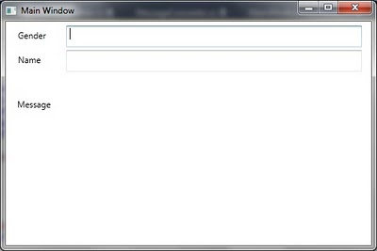](http://4.bp.blogspot.com/_fVxKMZVpfzU/TUzdMyY2SfI/AAAAAAAAAwY/jYWnnOIVisk/s1600/5.jpg)  
  
As you can see that empty message is displayed. Let's enter *F* for Gender and *Maria* for name. It would update the message as follows:  
  
[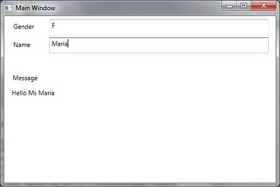](http://3.bp.blogspot.com/_fVxKMZVpfzU/TUzeO7ppKVI/AAAAAAAAAwg/xdBE8Gd-zU0/s1600/6.jpg)  
  
This might or might not be a requirement but let me explain what is going on. The re-evaluation of Converter is being done when either of Gender or Name of Student is updated. Since Gender is supposed to be used just as a ConverterParameter originally this re-evaluation might not be a desired behavior. It might be desired that converter is re-evaulated just when the actual intended bound property is updated. This update should just use the current value of the property specified as *ConverterParameter*. In order to prove this point just update the *Gender*to *M*. This would update the message as *Hello Mr. Maria*. This might not be desired.  
  
[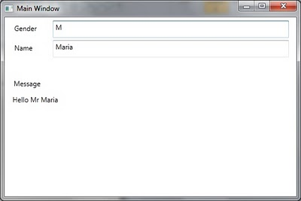](http://2.bp.blogspot.com/_fVxKMZVpfzU/TUzhfMwH6bI/AAAAAAAAAwo/X2x7QR7h8qM/s1600/7.jpg)  
  
**Introducing a Dependency Property in Converter and Using Binding Reflector:**  
*ConverterParameter* is a property of *Binding*. It is provided as a parameter to Convert and *ConvertBack*method of *Converter*whenever any update in *Source*or *Target*of *Binding*takes place.  
  
Let us update define a new Converter. It is an *IValueConverter*like our first example. It just has an additional *DependencyProperty*. We name this as *BindableConverterParameter*.

namespace WpfApplication_ConverterParameterBinding  
{  
 using System;  
 using System.Windows.Data;  
 using System.Windows;  
  
 class EnhancedMessageConverter : DependencyObject, IValueConverter  
 {  
 public static DependencyProperty BindableConverterParameterProperty =  
 DependencyProperty.Register("BindableConverterParameter", typeof(string),  
 typeof(EnhancedMessageConverter));  
  
 public string BindableConverterParameter  
 {  
 get { return (string)GetValue(BindableConverterParameterProperty); }  
 set { SetValue(BindableConverterParameterProperty, value); }  
 }  
  
 public object Convert(object value, Type targetType, object parameter, System.Globalization.CultureInfo culture)  
 {  
 string gender = BindableConverterParameter ?? string.Empty;  
 var name = value ?? string.Empty;  
  
 string salutation;  
  
 switch (gender)  
 {  
 case "M":  
 salutation = "Mr";  
 break;  
 case "F":  
 salutation = "Ms";  
 break;  
 default:  
 salutation = string.Empty;  
 break;  
 }  
  
 string message = string.Empty;  
  
 if (!(name == string.Empty && gender == string.Empty))  
 {  
 message = string.Format("Hello {0} {1}", salutation, name);  
 }  
  
 return message;  
   
 }  
  
 public object ConvertBack(object value, Type targetType, object parameter, System.Globalization.CultureInfo culture)  
 {  
 throw new NotImplementedException();  
 }  
 }  
}

Let's use this converter in the view.

<Window x:Class="WpfApplication_ConverterParameterBinding.MainWindowEnhanced"  
 xmlns="http://schemas.microsoft.com/winfx/2006/xaml/presentation"  
 xmlns:x="http://schemas.microsoft.com/winfx/2006/xaml"  
 xmlns:local="clr-namespace:WpfApplication_ConverterParameterBinding"  
 Title="MainWindowEnhanced" Height="300" Width="300">  
 <Window.Resources>  
 <local:EnhancedMessageConverter x:Key="messageConverter"   
 BindableConverterParameter="{Binding Gender}" />  
 </Window.Resources>  
 <Window.DataContext>  
 <local:MainWindowViewModel />  
 </Window.DataContext>  
 <Grid>  
 <TextBox Height="30" HorizontalAlignment="Left" Margin="84,6,0,0" Name="textBoxGender"   
 VerticalAlignment="Top" Width="412" >  
 <TextBox.Text>  
 <Binding Path="Gender" UpdateSourceTrigger="PropertyChanged" Mode="TwoWay" />  
 </TextBox.Text>  
 </TextBox>  
 <Label Content="Gender" Height="28" HorizontalAlignment="Left" Margin="12,6,0,0"  
 Name="labelGender" VerticalAlignment="Top" Width="58" />  
 <TextBox Height="30" HorizontalAlignment="Left" Margin="84,40,0,0" Name="textBoxStudentName"  
 VerticalAlignment="Top" Width="412" >  
 <TextBox.Text>  
 <Binding Path="StudentName" UpdateSourceTrigger="PropertyChanged" Mode="TwoWay" />  
 </TextBox.Text>  
 </TextBox>  
 <Label Content="Name" Height="28" HorizontalAlignment="Left" Margin="12,40,0,0"   
 Name="labelStudentName" VerticalAlignment="Top" Width="58" />  
 <TextBlock Height="164" HorizontalAlignment="Left" Margin="14,135,0,0" Name="textBlockMessage"  
 VerticalAlignment="Top" Width="479" >  
 <TextBlock.Text>  
 <Binding Path="StudentName" Converter="{StaticResource messageConverter}" />  
 </TextBlock.Text>  
 </TextBlock>  
 <Label Content="Message" Height="29" HorizontalAlignment="Left" Margin="11,102,0,0"  
 Name="label1" VerticalAlignment="Top" Width="129" />  
 </Grid>  
</Window>

Just look at the instantiation of the *Converter*in *Window.Resources* section. *BindableConverterParameter* in initialized to be bound to Gender property of the object. From our knowledge of Data Binding in WPF, we know that if we don't provide any Binding *Source* then it would be considered as *DataContext*.  
  
[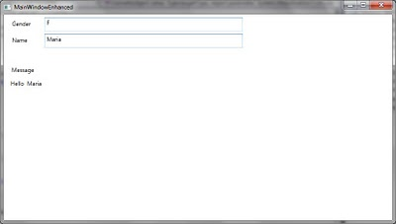](http://3.bp.blogspot.com/_fVxKMZVpfzU/TUzp9spu-3I/AAAAAAAAAww/9uS2QMaYnNI/s1600/8.jpg)  
  
Now keep changing the *Gender*and *Name*of Student in the view. No matter how many times we change the values entered, salutation title (Mr. / Ms.) never appears in the message text. As we see the definition of converter we know that this is only possible when*BindableConverterParameter*is null / Empty. Let's insert a break-point in the Convert method keep changing the data on the view.   
  
[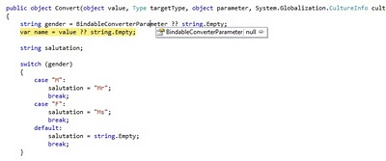](http://4.bp.blogspot.com/_fVxKMZVpfzU/TUzrCD1lFHI/AAAAAAAAAw4/pwRzi2d4mOk/s1600/9.jpg)  
  
This is as per the expectation. Basically *BindableConverterParameter* is always null. This is basically due to perceived over-simplification of the problem. We are binding to the *DataContext*in the *Resources*section. It must be remembered that *DataContext* is a *DependencyProperty* inherited through the Visual Tree. Since *Resources* section is not in the Visual Tree, it would not have the*DataContext*inherited resulting in no *Binding* at all. Because of same reason Relative Source Binding would also not work if we attempt to do it like this:

<Window.Resources>  
 <local:EnhancedMessageConverter x:Key="messageConverter"   
 BindableConverterParameter="{Binding RelativeSource={RelativeSource Self}, Path=DataContext.Gender}" />  
</Window.Resources>

As we have discussed that *Resources*can not use *DataContext*property of the view. But we know that *DataContext*can utilize any view it desires. Let us try to Bind the *BindableConverterParameter*to Gender property of *DataContext*in such a way that Binding is defined on DataContext in reverse direction. This can be done as follows:

<Window.Resources>  
 <local:EnhancedMessageConverter x:Key="messageConverter" />  
</Window.Resources>  
<Window.DataContext>  
 <local:MainWindowViewModel>  
 <local:MainWindowViewModel.Gender>  
 <Binding Source="{StaticResource messageConverter}" Path="BindableConverterParameter" Mode="OneWayToSource" />  
 </local:MainWindowViewModel.Gender>  
 </local:MainWindowViewModel>   
</Window.DataContext>

Now let us run the application. If we enter data in the text boxes, we realize that it results in update of the message to user. The greatest thing is that updates in *Gender*(used as *ConverterParameter*) is not causing re-evaluation of message. Message is re-evaluated only when the actual bound value to the message text block (*StudentName*) is updated. When we run the application and enter data [Gender=*F* and Name = *Maria*], the message is displayed as follows:  
  
[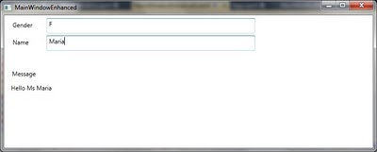](http://2.bp.blogspot.com/_fVxKMZVpfzU/TUzwH5PQaLI/AAAAAAAAAxA/ib8OuJlJfjg/s1600/10.jpg)  
  
Updating the Gender to M does not result in updating the display of message as follows:  
  
[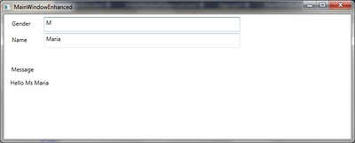](http://4.bp.blogspot.com/_fVxKMZVpfzU/TUzwILS5wuI/AAAAAAAAAxI/NllZ50W4HeI/s1600/11.jpg)  
  
As we update the name of student, the updated value of *BindableConverterParameter*is considered and view is updated with new message as follows:  
  
[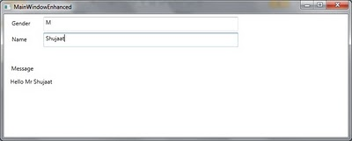](http://3.bp.blogspot.com/_fVxKMZVpfzU/TUzwIBaE2TI/AAAAAAAAAxQ/-iT1Jb73Acg/s1600/12.jpg)  
  
*Using Binding Reflector:*  
This is still not perfect solution because this is based on the assumption that view model is always instantiated by view. This is also possible that view model is instantiate separately and some other code assigns it to the *DataContext*property of view. Our logic would find limitation under this condition. In this case we are still instantiating the Converter in Resources section which is generally the norm.  
  
The best solution could be to bind the *Text*property of *Gender*text box to *BindableConverterParameter* property of the Converter in*OneWayToSource* mode. But again, this is already bound to the Gender property of *DataContext*.   
  
In WPF, a *DependencyProperty*might be the source for a number of Binding but it might be the *Target*of only one *Binding*. Although because of availability of various Binding modes, the difference between Source and Target of Binding in the real sense is really vague but *Target*is referred to the Property on which the binding is defined and *Source*is considered as the property which is actually being used for Binding to *Target*.  
  
Based on the above discussion, this seems to be the end of world. But never lose hope! Let us invent a new tool. We name this tool as*Binding Reflector*. We will be using this to pass the updates in one dependency property to another Dependency Property. In our example we will be using it to Bind between *Gender*property of *DataContext*to *BindableConverterParameter*property of Converter instantiated in *Resources*section of Window. In order to use the DataContext, it must be an element in the *Visual Tree* of view. Let's define it as a *FrameworkElement*.

namespace WpfApplication_ConverterParameterBinding  
{  
 using System.Windows;  
 using System.Windows.Data;  
  
 class BindingReflector : FrameworkElement  
 {  
 public static DependencyProperty SourceProperty =  
 DependencyProperty.Register("Source", typeof(object), typeof(BindingReflector),  
 new FrameworkPropertyMetadata()  
 {  
 DefaultUpdateSourceTrigger = UpdateSourceTrigger.PropertyChanged,  
 PropertyChangedCallback = OnSourceChanged  
 });  
  
 public object Source  
 {  
 get { return GetValue(SourceProperty); }  
 set { SetValue(SourceProperty, value); }  
 }  
  
 public static DependencyProperty TargetProperty =  
 DependencyProperty.Register("Target", typeof(object), typeof(BindingReflector),  
 new FrameworkPropertyMetadata() { DefaultUpdateSourceTrigger = UpdateSourceTrigger.PropertyChanged });  
  
 public object Target  
 {  
 get { return GetValue(TargetProperty); }  
 set { SetValue(TargetProperty, value); }  
 }  
  
 private static void OnSourceChanged(DependencyObject d, DependencyPropertyChangedEventArgs e)  
 {  
 var reflector = (BindingReflector)d;  
 if (reflector.Source != reflector.Target)  
 {  
 reflector.Target = reflector.Source;  
 }  
 }  
 }  
}

As you can see that it is a FrameworkElement with just two Dependency properties i.e. *Source*and *Target*. Source is registered with a*PropertyChangedCallBack*. In the callback handler, we are just copying the value of Source Property to Target property. This Binding Reflector will be used in the view. With appropriate Binding, we will be obtaining the actual desired result. Let us define a new view as follows:

<Window x:Class="WpfApplication_ConverterParameterBinding.MainWindowEnhancedReflector"  
 xmlns="http://schemas.microsoft.com/winfx/2006/xaml/presentation"  
 xmlns:x="http://schemas.microsoft.com/winfx/2006/xaml"  
 xmlns:local="clr-namespace:WpfApplication_ConverterParameterBinding"  
 Title="MainWindowEnhancedReflector" Height="300" Width="585">  
 <Window.Resources>  
 <local:EnhancedMessageConverter x:Key="messageConverter" />  
 </Window.Resources>  
 <Window.DataContext>  
 <local:MainWindowViewModelEnhanced />  
 </Window.DataContext>  
 <Grid>  
 <local:BindingReflector Target="{Binding Mode=OneWayToSource, Source = {StaticResource messageConverter}, Path=BindableConverterParameter}"  
 Source="{Binding Path=Gender, Mode=OneWay}" />  
 <TextBox Height="30" HorizontalAlignment="Left" Margin="84,6,0,0" Name="textBoxGender"   
 VerticalAlignment="Top" Width="412" >  
 <TextBox.Text>  
 <Binding Path="Gender" UpdateSourceTrigger="PropertyChanged" Mode="TwoWay" />  
 </TextBox.Text>  
 </TextBox>  
 <Label Content="Gender" Height="28" HorizontalAlignment="Left" Margin="12,6,0,0"  
 Name="labelGender" VerticalAlignment="Top" Width="58" />  
 <TextBox Height="30" HorizontalAlignment="Left" Margin="84,40,0,0" Name="textBoxStudentName"  
 VerticalAlignment="Top" Width="412" >  
 <TextBox.Text>  
 <Binding Path="StudentName" UpdateSourceTrigger="PropertyChanged" Mode="TwoWay" />  
 </TextBox.Text>  
 </TextBox>  
 <Label Content="Name" Height="28" HorizontalAlignment="Left" Margin="12,40,0,0"   
 Name="labelStudentName" VerticalAlignment="Top" Width="58" />  
 <TextBlock Height="164" HorizontalAlignment="Left" Margin="14,135,0,0" Name="textBlockMessage"  
 VerticalAlignment="Top" Width="479" >  
 <TextBlock.Text>  
 <Binding Path="StudentName" Converter="{StaticResource messageConverter}" />  
 </TextBlock.Text>  
 </TextBlock>  
 <Label Content="Message" Height="29" HorizontalAlignment="Left" Margin="11,102,0,0"  
 Name="label1" VerticalAlignment="Top" Width="129" />  
 </Grid>  
</Window>

Just have a look at the first child of *Grid*. It is the same *BindingReflector*that we have created. You can see that we have used specific*Binding*modes for Source and Target *Binding*. For Source, it is One Way Binding so that it could receive value updates from *Source*. For*Target*property, it is set as *OneWayToSource*so that value changes as assigned in *SourceChanged*call back could be passed to the*Target*.   
  
One important point is that we have bound Target property before Source property here. This is deliberate action. Basically as we know that using a *FrameworkElement*like this causes the default constructor of *FramworkElement*to be executed. It then assigns the specified properties to the values as specified. If we specify *Source*before *Target*here then the initial values of Source will be copied to the *Target*but they wouldn't be assigned to the *Binding*defined later. But if we first define binding for Target then as we would update the value of *Target*it would be available in *BindableConverterParameter*.  
  
Now we run the application. The behavior is similar to our previous example. It is also not causing the Binding to re-evaluate when just*BindableConverterParameter*is updated. It is only updated when the actual Binding Source i.e. *StudentName*is updated. Let's run this to see this behavior:  
  
[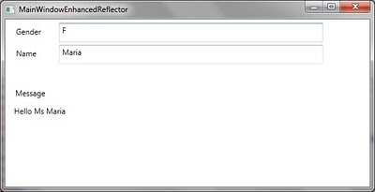](http://1.bp.blogspot.com/_fVxKMZVpfzU/TUz87fUN0qI/AAAAAAAAAxY/jgDkgL7ZwJk/s1600/13.jpg)  
Now update Gender followed by Name and see the message updated as follows:  
  
[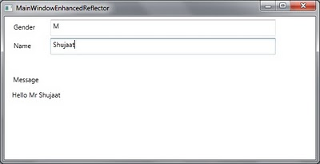](http://3.bp.blogspot.com/_fVxKMZVpfzU/TUz87uU2opI/AAAAAAAAAxg/s_QWyI-Eqdc/s1600/14.jpg)  
  
**Note:**  
In this post, we have introduced *Binding Reflector*. We can also use it to bind between dependency properties of two different*Resources*.

To associate a converter with a [MultiBinding](http://msdn.microsoft.com/en-us/library/system.windows.data.multibinding.aspx), create a class that implements the **IMultiValueConverter** interface, and then implement the [Convert](http://msdn.microsoft.com/en-us/library/system.windows.data.imultivalueconverter.convert.aspx) and [ConvertBack](http://msdn.microsoft.com/en-us/library/system.windows.data.imultivalueconverter.convertback.aspx) methods.

Individual bindings in the collection can have their own value converters. For more information, see [IValueConverter](http://msdn.microsoft.com/en-us/library/system.windows.data.ivalueconverter.aspx).

[**Examples**](javascript:void(0))

[MultiBinding](http://msdn.microsoft.com/en-us/library/system.windows.data.multibinding.aspx) allows you to bind a binding target property to a list of source properties and then apply logic to produce a value with the given inputs. This example demonstrates how to use [MultiBinding](http://msdn.microsoft.com/en-us/library/system.windows.data.multibinding.aspx).

In the following example, NameListData refers to a collection of PersonName objects, which are objects that contain two properties, firstName and lastName. The following example produces a [TextBlock](http://msdn.microsoft.com/en-us/library/system.windows.controls.textblock.aspx) that shows the first and last names of a person with the last name first.

**XAML**

<Window

xmlns="http://schemas.microsoft.com/winfx/2006/xaml/presentation"

xmlns:x="http://schemas.microsoft.com/winfx/2006/xaml"

xmlns:c="clr-namespace:SDKSample"

x:Class="SDKSample.Window1"

Width="400"

Height="280"

Title="MultiBinding Sample">

<Window.Resources>

<c:NameList x:Key="NameListData"/>

<c:NameConverter x:Key="myNameConverter"/>

...

</Window.Resources>

...

<TextBlock Name="textBox2" DataContext="{StaticResource NameListData}">

<TextBlock.Text>

<MultiBinding Converter="{StaticResource myNameConverter}"

ConverterParameter="FormatLastFirst">

<Binding Path="FirstName"/>

<Binding Path="LastName"/>

</MultiBinding>

</TextBlock.Text>

</TextBlock>

...

</Window>

To understand how the last-name-first format is produced, let's take a look at the implementation of the NameConverter:

**C#**

[**VB**](javascript:%20CodeSnippet_SetLanguage('CodeSnippetContainerLang',%20'Programming',%20'Visual%20Basic');)

public class NameConverter : IMultiValueConverter

{

public object Convert(object[] values, Type targetType, object parameter, CultureInfo culture)

{

string name;

switch ((string)parameter)

{

case "FormatLastFirst":

name = values[1] + ", " + values[0];

break;

case "FormatNormal":

default:

name = values[0] + " " + values[1];

break;

}

return name;

}

public object[] ConvertBack(object value, Type[] targetTypes, object parameter, CultureInfo culture)

{

string[] splitValues = ((string)value).Split(' ');

return splitValues;

}

}

NameConverter implements the **IMultiValueConverter** interface. NameConverter takes the values from the individual bindings and stores them in the values object array. The order in which the [Binding](http://msdn.microsoft.com/en-us/library/system.windows.data.binding.aspx) elements appear under the [MultiBinding](http://msdn.microsoft.com/en-us/library/system.windows.data.multibinding.aspx)element is the order in which those values are stored in the array. The value of the [ConverterParameter](http://msdn.microsoft.com/en-us/library/system.windows.data.multibinding.converterparameter.aspx) attribute is referenced by the parameter argument of the [Converter](http://msdn.microsoft.com/en-us/library/system.windows.data.multibinding.converter.aspx) method, which performs a switch on the parameter to determine how to format the name.